more than 5,000 entrants from 21 coun­
tries had built planes and mailed them to
traveled, aerobatic ability and appear­ ance in the air.

by MICHAEL ROZEK

THESE EXEMPLARY AIRCRAFT GAVE NEW MEANING TO THE TERM 'PAPER ROUTE'

On the afternoon of June 9 at Seattle's Kingdome, thousands of people threw paper onto the field from the upper deck. Nothing would stop them.
No harm done, though. The occasion was .the eighth annual World Indoor Pa­ per Airplane Championships . Actually, the title is a bit misleading. The WIPAC isn't really global, or even particularly competitive, but just a wacky Seattle tra­ dition dreamed up in 1978 by a local councilman. This year's championships drew 5,000 people (admission was free) to the Kingdome's top level. There com­ petitors folded 11 X 17-inch sheets of printed bond into many varieties of pa­ per-airplane muster, wrote their names on them, took aim at .fluorescent circles marked on the artificial turf below and let fly. If a plane landed in a circle, 'i'ts thrower would win a corresponding prize, perhaps a Ronald McDonald wrist­ watch or an all-expenses-paid trip to Walt Disney World. And if a plane flew through the open sunroof of a Volks­ wagen Golf, its pilot would win the car. (Nobody did.) Since entrants had to make planes from paper sold by tourna­ ment sponsors to benefit a local food bank (three sheets for a dollar), each toss also helped a worthy cause.
Meanwhile, eight serious paper-plane buffs-six from Japan, two from the U.S.-were standing quietly down by second base. All had been winners in an­ other event, The Second Great Interna­ tional Paper Airplane Contest, held in the Kingdome in late May. Now they were back in Seattle to receive their med­ als and submit their craft to an exhibi­ tion launch or two before the frenzied WlPAC crowd.
The earlier contest had been on a
somewhat higher plane than this event and had been sponsored by Seattle's Mu­ seum of Flight, the Smithsonian's Na­ tional Air and Space Museum, the Na­ tional Science Foundation, Science 85 magazine, White Wings-a Japanese brand of paper glider-and Japan Air Lines. Responding to ads in The New York Times, wire-service stories and Voice of America shortwave broadcasts,
the Museum of Flight. Each craft had to be constructed entirely of paper (glue and tape were allowed for bonding) but was not limited by length, weight or de­ sign. The contest judges- mostly retired pilots who had both knowledge of aero­ dynamics and good throwing arms­ brought the planes to the Kingdome to toss them during three days of competi­ tion. The judges looked for winners in such categories as time aloft, distance

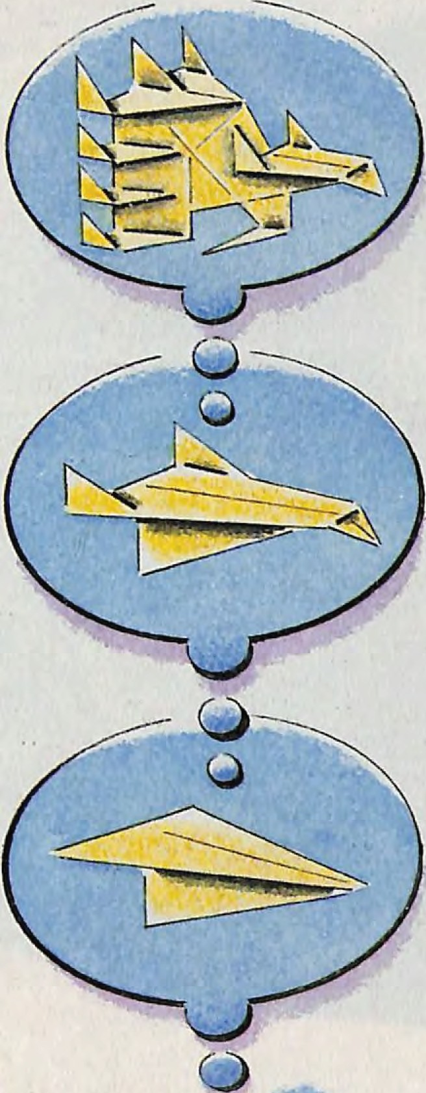PHILIP ANDERSON

/-1C,-S-
For a craft to win, it had to be some­ thing out of the ordinary. "Since child, hobby," explained one victor, 45-year­ old Akio Kobayashi of Tokyo, when a re­ porter asked him why he liked building and throwing paper bombers . Kobaya­ shi's plane-only 9" nose to tail , 8Yi" wingtip to wingtip, 2W' high-looked like the sort of glider you'd find in a cere­ al box, but it was actually an aerodynam­ ic masterpiece. Entered in the profes­ sional division of the distance category ("professional" because Kobayashi is an engineer), it flew 122' 8"-16 feet farther than its nearest competitor in that cate­ gory and 2' 8" farther than the Wright brothers' plane flew back in I 903.
"My greatest pleasure is to see some­ thing I've made fly in the sky,"translated an interpreter for Masakatsu Omori of Fukuoka, Japan, a university student whose studies in aerodynamics helped him win the professional esthetics cate­ gory. Omori's paper plane, only seven inches from edge to edge and eight inches from nose to tail , resembled a Mtibius strip. Instead of merely flying, it had flut­ tered-as delicately as a lotus blossom wafting on a breeze-for eight seconds
before descending , to the judges ' aaahs and applause.
What did all this paper-airplane busi­ ness add up to? Ifnothing else, it brought a number of the pastime's many enthusi­ asts out of the woodwork. Says the Muse­ um of Flight's Ali Fujino, "Throughout history, there's been little said about pa­ per planes. The Chinese had a related in­ terest 'in kites, of course. And Leonardo da Vinci wrote about paper flight, but he didn't make any drawings of paper air­ craft." In fact, adds Fujino, the only book on the subject until recently was Paper Planes, a 1939 collection of essays by Englishman H.G.G. Herklots. But the event's success indicates that anyone in­ terested in writing a book on the subject might consider beginning work at once. At last, the field may be crowding.
Still, when Fujino began to organize The Second Great International Airplane Contest as a way of promoting the Muse­ um of Flight's development drive, she wasn't sure there would be much interest. The first contest, sponsored by Scientific American magazine in 1967 at the site of the New York World's Fair that had tak­ en place there two years earlier, attracted 11,000 entries. The next year, though, the
continued

SIDELINE continued

com pet1t1on was discontinued; it had simply been too much work to pull to­ gether. "Ever since," Fujino says, "there have been small regional or college con­ tests periodically around the country, but nothing very organized ."
But she had forgotten about the Japa­ nese. "I went to Japan on vacation and discovered this hotbed of paper-airplane activity there," Fuji no says. "The Japanese actually have little·amalgams of fliers called Paper Airplane Sport Clubs. And paper planes are so popular that Dr. Yasuaki Ninonmiya, the sensei [mas­ ter] of the movement , has written an eight-volume set of books on paper-air­ plane flight and his designs, called Col lection of High Performance Paper Planes. He also has two condominiums in Tokyo, something really·rare with liv ing space at so great a premium. One condo is for him , and the other houses his 600 airplanes." Not surprisingly, the number of Japanese entries in The Second Great International Airplane Contest was second only to that of the United States.
What was surprising, though, was how creative or technically ornate many of the planes were. Adam and Jack Hansen of Newcastle, Maine planned theirs with the help of a Macintosh computer. An entry called The Flying Pineapple looked exactly like what its name sug­ gests. There was a "suicide plane, " which had taped to it a match and a note read­ ing, "If I don't win, do the honorable th i ng." (The judges didn't.) Two entries from Mr. G. Pumple of Calgary, Alberta ,
made out of what he called "British toilet pa per," were so light they didn't even register on the contest's scales. James Zongker , an aeronautical engineer for the Boeing Company in Wichjta, Kans., worked 75 hours building a detailed model of an F-14 Tomcat from index cards and whjte bond . A plane shaped like a napkin ring came in from Saudi Arabia. Seattle resident Jeff Brown's Flying Lizard, one of the two largest planes entered in the contest, had a wing­ span of three feet, while New Yorker
Howard Fink's plane, the smallest, was only an inch long, with a 1.5" wingspan. Even Utah Senator Jake Garn got i nto the act, submitting as an honorary entry the first paper airplane flown in space;
Garn had flown it during his Space Shut­ tle voyage in April.
Because the judging was based on how well the planes flew, almost all the entries

were sent with launching instructions . "Throw hard and straight," read one set. "Lunge forward as you throw," read an­ other. "Our favorite," says Fujino, "was a plane from Alaska with 22 pages of handwritten directions. We dubbed them 'The Flight Manual.' " The Japa­ nese wrote detailed information in Eng­ lish right on their planes , followed by a note that said, "If you can read -Japanese, read these directions," and then gave even more specific details in Japanese characters. "I suppose that if you spend 1 75 hou rs making a paper airplane, like one contestant did, you're allowed a little bit of personal paranoia about some strange judge trashing it," says Fujino.
When it came down to whose planes flew the farthest and longest, it was the const ruction more than the launching t ha t counted . Most of the Japanese de­ signs were "laminated," or coated with glue, a legal technique that gave the planes more stability as well as added weight. The most successful entries had
year-old Robert Meuser's plane looked like a conventional paper dart, and flew 141 ' 4" to win the nonprofessional divi­ sion of the distance category-the same event he'd won in the first contest 18 years earlier with a different model. "You tweak one wing a hundredth of an inch, or the humidity changes, and an elaborate design can be thrown off," says Meuser, a veteran of model-plane build­ ing and a contributor to Model Aviation magazine. "Still, a person shouldn't get too serious about paper airplanes."
Eltin Lucero's plane, winner in the ju­ nior (age 14 and under) division of the distance category, proved Meuser's point. Eltin, a sixth-grader from Pueblo, Colo., came up with a perfect design by acci­ dent. "He just took an 8W' x 12W' piece of paper and folded it, like most people would,"says Fujino. "And the far­ thest he was able to fly it at home before entering it was 22 feet. But our judges were adults with good arms." So good, in fact , that Eltin's craft flew 114' 8".
as lucky as Eltin. They weren 't , though. The year before , Joe Bean, 16, of Renton, Wash. had thrown a plane into a circle marked WALT DISNEY WORLD. But this year he was having his problems. "I guess there's a lot of luck involved," Joe sighed, while folding yet another plane. "I've gotten planes close to the Disney World circle again, but then they keep turning. There's some kind of air current down on the field . Someone should close the doors." Eventually, John Vincent , a 33-year-old Australian who works for Boeing, flew his plane closer to the circle than anyone else and won the Walt Dis­ ney World trip.
"The Japanese call paper airplaning a sport," says Fujino, watching the In­ door Paper Airplane festivities. "But for Americans , it involves a different kind of competitive sense than a lot of sports we play. Throwing a paper airplane can be personal and lyrical. It's part fantasy and part escape. In a few minutes' time, it's a way to rise above the humdrum." END

wings and tail fins modeled after those on Two weeks later, that other group of

real planes. The two winning American designs were even simpler. Sixty-three-
paper-airplane pilots crowded the top level of Seattle's Kingdome, hoping to be
Michael Rozek lives in Spokane, Wash. He
has written a number of articles for SJ.

